FRESHER_DEVELOPER_PROFILE

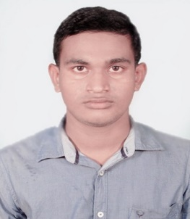**SUBHRANSU SEKHAR MOHANTY**   
[**ssmohanty153@gmail.com**](mailto:ssmohanty153@gmail.com)

**+91 9090142958**

**+91 7978568916**

**CAREER OBJECTIVE**

Interested to build a career with an organization, where in, I can implement my Theoretical, Logical, Technical skills in the practical real life environment with committed & dedicated people, which will help me to explore myself fully and realize my potential, Willing to work as a key player in challenging & creative environment

**ACADEMIC PROFILE**

* **B-TECH(MECHANICAL)** from GANDHI INSTITUTE FOR TECHNOLOGY,BBSR with **71.10% (2013-2017)**
* INTERMIDIATE (SCIENCE) from UN COLLEGE SORO,BALASORE with **56.33% (2011-2013)**
* **MATRICULATION** from UN ACADEMY KHIRKONA,BALASORE with **75.33% (2011)**

**SKILLS SUMMARY**

**JAVA**

* Good knowledge in oops concept.
* Good knowledge in Interface and Abstract classes.
* Good knowledge in Exception Handling.
* Excellent understanding of polymorphism.
* Inheritance, method overriding, method overloading.

**TRAINING CERTIFICATION**

* **Software Development** Training in **Jspiders** Bangalore.

**TECHENICAL SKILLS**

Academic Projects:

|  |  |
| --- | --- |
| **Programming Languages** | JAVA,J2EE,SPRINGS,HIBERNATE |
| **IDE’s** | ECLIPSE |

**PROJECT**

**PROJECT NAME: FEE REPORT PROJECT**

**PROJECT SUMMARY**:A fee report software where admin can add/view/delete accountant and accountant can add/view/delete student, check due fee and logout.

**Roles and Responsibilities:**

* Coding of the project.
* Take the decision which tool be used like (Eclipse).
* Identifying different Scenarios.

**PERSONALs DETAILS**

* **Date of Birth :-** 09-06-1996
* **Nationality :-** INDIAN